Team 9 Test Plan

To: Professor Pisano

From: Team 9

Team: 9

Date: 11/18/2021

Subject: Test Plan

# 1.0 List of Materials

Hardware:

Raspberry Pi 4 B (with 32GB SanDisk SDHC Class 10 card)

Raspberry Pi fans

BerryGPS-IMUv4 (Part number: 8542129523)

Raspberry Pi 4 Camera IR ()

QWIIC Connector and Cable for Raspberry Pi

15W Power Adapter (Pi4)

Mini HDMI to HDMI cable

Active GPS antenna

Software:

C language:

Data collection, from IMU to readable txt file

Python Script:

GPS receiver, from GPS to txt file

Recording video in h.264 format

Image Analysis to capture the change of Airspeed dial

XDR File:

The input file to the Xplane simulator.

Google Colab notebook:

Scripts to calculate the angle of an airspeed dial

# 2.0 Equipment Setup

Raspberry Pi4:

1. Enable i2c interface
2. Enable Serial port interface
3. Disabled Serial console
4. Run IMU_interface.c
5. Run GPS.py
6. Run Test.py

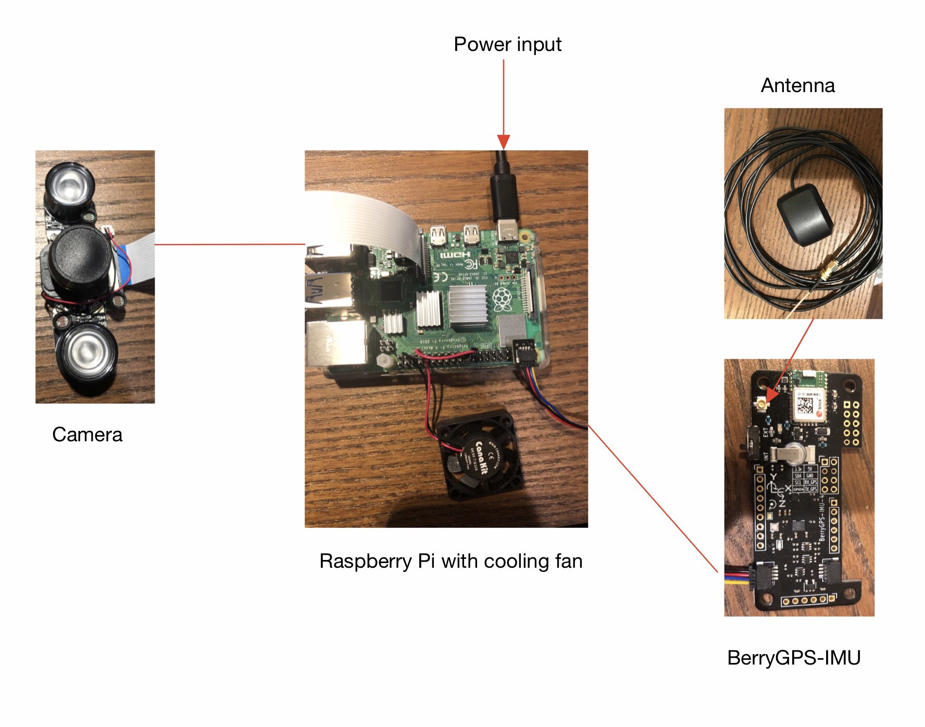

# 3.0 Test Procedure

Test 1: Extract data from sensors

1. Place the BerryGPS-IMU outdoor
2. Get the result data which includes barometer, temperature, altitude, longitude, latitude, pitch, roll, yaw from output data file.
3. Place the BerryGPS-IMU indoor
4. Get the same result data again
5. Compare the result data with the actual data which could be referenced on the Internet and make sure the system is working properly and precisely.

Test 2: Calculate angle of airspeed dial from image

1. Generate a toy image of an airspeed dial
2. Upload the image to the Google Colab notebook
3. Set the filename specified in the notebook to the name of the file
4. Run all the cells in the Synthesized Image section
5. See an output image of the dial and a calculated angle

Test 3: View .fdr file in X-Plane

1. Initiate Xplane 11 on Windows/MacOS/Linux.
2. Use a generated .FDR File to run from modelled data and altering the highlighted factors above.
3. Load and initiate the Available File .FDR, .SIT, .REP.
4. Verify data input against Flight Dashboard

# 4.0 Measurements and Criteria for Success

Test 1: Extract data from sensors

1. Roll, Pitch, and Yaw: The output data of roll, pitch, and yaw match the movement of the BerryGPS-IMU.
2. GPS: The output data of GPS will show it is trying to search the satellite signal.
3. Camera: The camera will record the video under any light circumstance.
4. Output Data: The output data of altitude will match the altitude of Boston.

Test 2: Calculate angle of airspeed dial from image

1. Output image: The output image of the dial should include a line overlaid on the needle
2. Calculated angle: The output angle (in degrees) should match the angle of the dial in the image

Test 3: View .fdr file in X-Plane

| Test Case | Runtime | Success Case |
| --- | --- | --- |
| .FDR Sample 20 Seconds Linear Track | 20s | Runs with a steady speed (250 Knt) |
| .SIT/.REP Sample Alteration & Data Recording | 10s | Writes Data.txt while running |
| .FDR Altered 20 seconds Linear Track | 20s | Accelerates & decelerates based on provided data |
| .FDR Altered 1 minute Right Embankment | 20-60s | Runs, Turns in one direction based on applied coordinates |